PHOTO ESSAY: STRUGGLES OF FAMILIES IN DROUGHT-AFFECTED NORTHERN KENYA

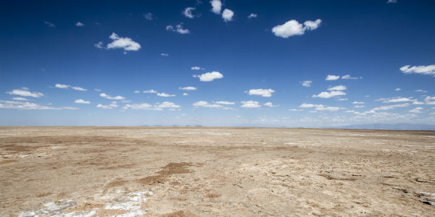

SOS Children’s Villages has initiated emergency relief efforts to assist children and families grappling with drought and food insecurity across four East African nations. The response, spanning Ethiopia, Kenya, South Sudan, and Somalia, prioritizes food aid, child protection, and nutritional support and monitoring. Depending on local requirements, temporary shelter may be provided to vulnerable children and families. In Kenya alone, 2.6 million individuals out of the country’s 46 million population face food shortages, with almost 360,000 children, pregnant women, and breastfeeding mothers classified as severely malnourished. Livestock losses resulting from water scarcity impact both food supplies and the income potential of rural households.

In Marsabit County, among the hardest-hit regions in Kenya, the situation reflects a broader regional crisis as water and food scarcities pose increasing risks to children and families. Home to approximately 300,000 people, Marsabit County stands as an arid area in northern Kenya adjacent to Ethiopia. The ongoing drought represents one of the most severe in recent memory. The remoteness of many communities complicates the delivery of urgently needed assistance. Similar to numerous families across drought-affected areas of East Africa, those in Marsabit endure a daily battle for survival, with their prospects for the future growing increasingly grim. This photo essay captures their hardships.

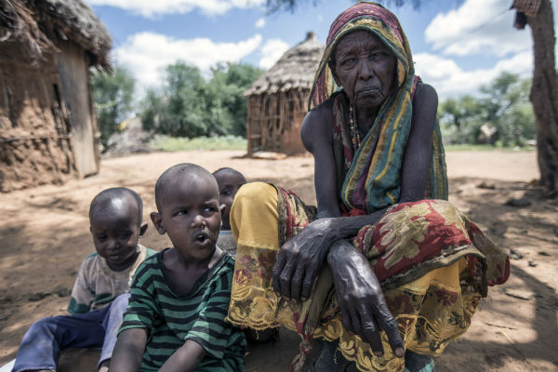Goalgallu Boru Ali, the head of a family of 13, resides in Dambala Fachana, a village of 5,000 inhabitants near the Ethiopian border. In mid-May, her family lost all 50 cows crucial for their livelihood. Many of her children have been compelled to leave home and seek employment elsewhere. She sits with three of her grandchildren who are no longer attending school. Expressing her anguish, Goalgallu asks, “We are lost without our cattle. What will we do now? How will my family survive?”

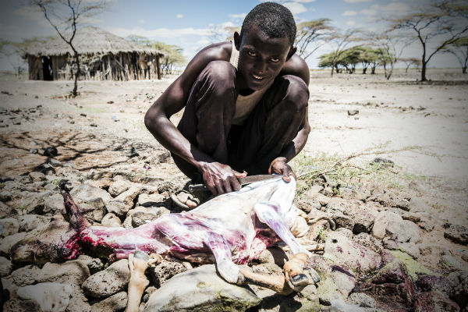

In Maikona village, the drought has resulted in the tragic loss of livestock. Livestock prices have plummeted, forcing pastoralists to slaughter their goats to salvage meat. Village leaders estimate that over 95% of the population has been affected by livestock losses and are now reliant on food aid.

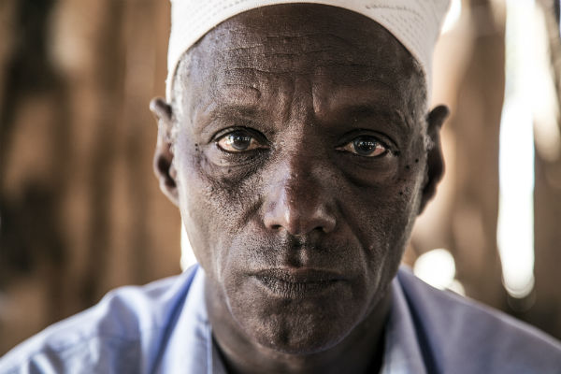Jiba Okotu Halakhe, a village elder in Maikona, lost all his livestock. “I have never witnessed anything like this before, and now I fear for the future,” Jiba laments. “We waited a long time for the rains, and when they finally arrived two weeks ago, they claimed the last of my livestock.”

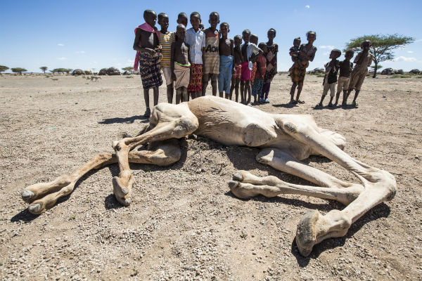 “When the camels start dying, you know there’s a serious problem,” remarks Moses Galoro, the chief of Kargi village. The camel seen here died of thirst the previous day. Too cumbersome to move and too decomposed to eat, the carcass will be left for hyenas.

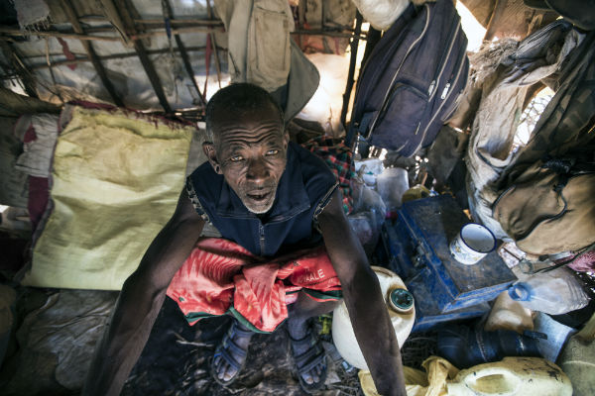To confront the severe challenges posed by the drought, the Kenyan government has implemented various initiatives, including food aid and the rollout of cash transfer programs based on a credit scheme. Holathura Eisimuobanai hopes to feed his six children using the credit program. “We’ll have to repay them, but that’s a worry for another day. For now, we need to eat,” he says.

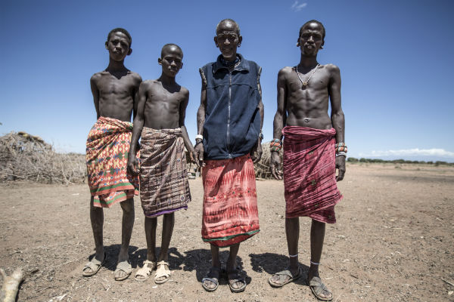Holathura’s wife and daughters embarked on a 20-kilometer journey to Kargi village to apply for a cash transfer using a government credit program and purchase food for the family. “They left three days ago,” Holathura shares, “And we haven’t had anything to eat since. I don’t know when she’ll return, and my sons are hungry.”

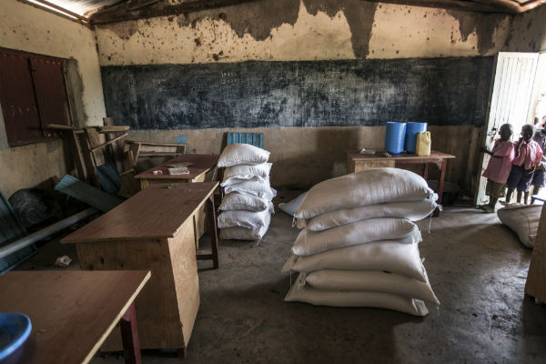The government recently delivered 500 kilograms of maize meal to Dambala Fachana School. While this assistance is appreciated, headmaster Wako Liban notes, “It’s not sufficient, and these deliveries are too infrequent.” The school has asked students to bring two liters of water to class daily due to frequent water shortages on site. Liban acknowledges the challenges, stating, “The community here consists of pastoralists. Due to the drought, many people have moved away from this area in search of better grazing. They take their children with them, and these kids don’t return to school.”